‘

The COSMIC Functional Size Measurement Method
Version 4.0.2

ACME Car Hire Case Study

VERSION 1.0.1

August 2018

Table of Contents

1 ABOUT THIS CASE STUDY 3
1.1 Introduction 3
1.2 How to use this ACME case study 3
2 THE MEASUREMENT TASK AND THE SCREEN SHOTS 4
2.1 The Measurement Purpose and Scope 4
2.2 The Screen Shots 4
2.2.1 Screen 1. List Customers 5
2.2.2 Screen 2. List of Customers 6
2.2.3 Screen 3. Customer Summary 6
2.2.4 Screen 4. View/Update Customer Details 7
2.2.5 Screen 5. Print Preview of Customer invoice 8
2.2.6 Screen 6. Error: Customer not found 9
2.2.7 Screen 7. Create Customer Details 10
3 MAPPING AND MEASUREMENT PHASES 12
3.1 Navigation of the screens via the control buttons 12
3.2 Mapping the physical screen displays to the COSMIC concepts 13
3.3 Identifying the functional processes 13
3.4 Identifying the objects of interest 14
3.5 Identifying the data movements of the functional processes 15
3.6 Exploring hidden functionality - Exercises 18
3.7 ACME Car Hire System. Summary COSMIC size measurement. 21
REFERENCES 22
ACKNOWLEDGEMENTS 23
VERSION CONTROL 23
CHANGES IN V1.0.1 FROM V1.0 OF THIS GUIDELINE 24
CHANGE REQUESTS, COMMENTS, QUESTIONS 24

Copyright 2018. All Rights Reserved. The Common Software Measurement International Consortium (COSMIC). Permission to copy all or part of this material is granted provided that the copies are not made or distributed for commercial advantage and that the title of the publication, its version number, and its date are cited and notice is given that copying is by permission of the Common Software Measurement International Consortium (COSMIC). To copy otherwise requires specific permission.

1

1 ABOUT THIS CASE STUDY

1.1 Introduction
This Case Study presents the results of applying the COSMIC Functional Size Measurement method, version 4.0.2, to measure some of the implemented functionality of the ACME Car Hire System, as described in Chapter 2.
General information about the software application to be measured:
- Application domain: Business Application
- This is an implemented on-line system for which only some screen shots are available. These must be measured. Apart from a small amount of background information there is no other information available, for example there is no statement of requirements.

1.2 How to use this ACME case study
This case study aims to be suitable for new users of the COSMIC method who have at least read the ‘Introduction to the COSMIC method’ [1] or have received some introductory training in the method. Ideally, readers should have read the Measurement Manual [2]. It is also assumed that the reader is generally familiar with on-line business application software.
The purpose of the ACME case study is to show how to apply the COSMIC method to measure an existing implemented on-line business application. This type of measurement is often required after a project is finished to determine the size of the software actually delivered.
Often when a system has been in existence for some years, there may be no up-to-date documentation to help the Measurer. Normally in practice the Measurer should find an expert on the system to explain how it works but sometimes, as in this case, the challenge is to do the measurement just by examining the input and the output.
The ACME case aims to support the following teaching points on the COSMIC method:
- Identifying functional processes from the physical display screens (they do not always map one-to-one).
- Identifying the objects of interest about which data must be entered or is displayed.
- Identifying the data movements of a functional process, including that alternative processing paths may or may not lead to identifying additional data movements.
- The need to recognise that an enquiry functional process may or may not be identical to an ‘enquire-before-update process’. Only one enquiry functional process should be counted per application if the FUR are identical for both situations. But in this case the FUR are different for the two situations.
- The COSMIC rules for ignoring ‘Control Commands’ and Menu selections and for measuring ‘Error/Confirmation messages’.
- The software to be measured may have functionality that cannot be properly identified just from the physical input and output screens. The Measurer should ask questions of a system expert to find out details of any ‘hidden’ functionality. The case illustrates the very important lessons to be learned on the importance of identifying and measuring any ‘hidden’ functionality of installed software.
2

2 THE MEASUREMENT TASK AND THE SCREEN SHOTS

2.1 The Measurement Purpose and Scope
The Purpose is defined to the Measurer as ‘to measure the functionality of the ACME Car Hire system represented by the screen-shots shown in section 2.2 (which define the Scope of the measurement).
The precision of the measurement will depend on what can be learned from examining the physical screens and what might be learned from asking an expert about how the system works.
The Measurer accesses and uses the system by entering trial data, finding the set of seven screens shown that must be measured. Figure 2.1 shows the screen titles and the sequence in which they are described in section 2.2; this is also one of the ways they may be navigated.
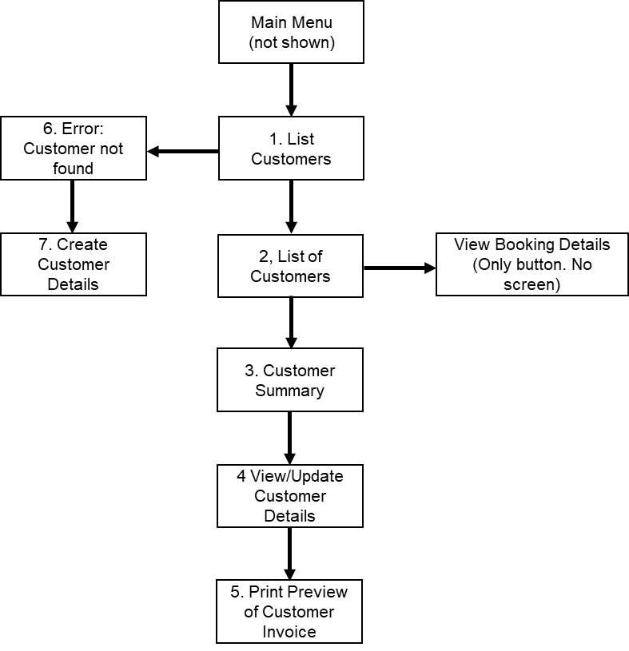
Figure 2.1 - ACME screens that must be measured
It is evident that the only functional user of the software is a human who enquires on and enters data about ACME Car Hire customers and their bookings.
Figure 3.1 (see section 3.1) shows the names on the control buttons and all the ways in which the screens may be navigated.

2.2 The Screen Shots
The User selects ‘View Customer’ from the Main Menu (not shown) which results in displaying the data entry screen 1

2.2.1 Screen 1. List Customers
The User enters the title and name of a customer, a Mr John Smith in this case, and presses the ‘Search’ button to enquire if the customer exists in the system.
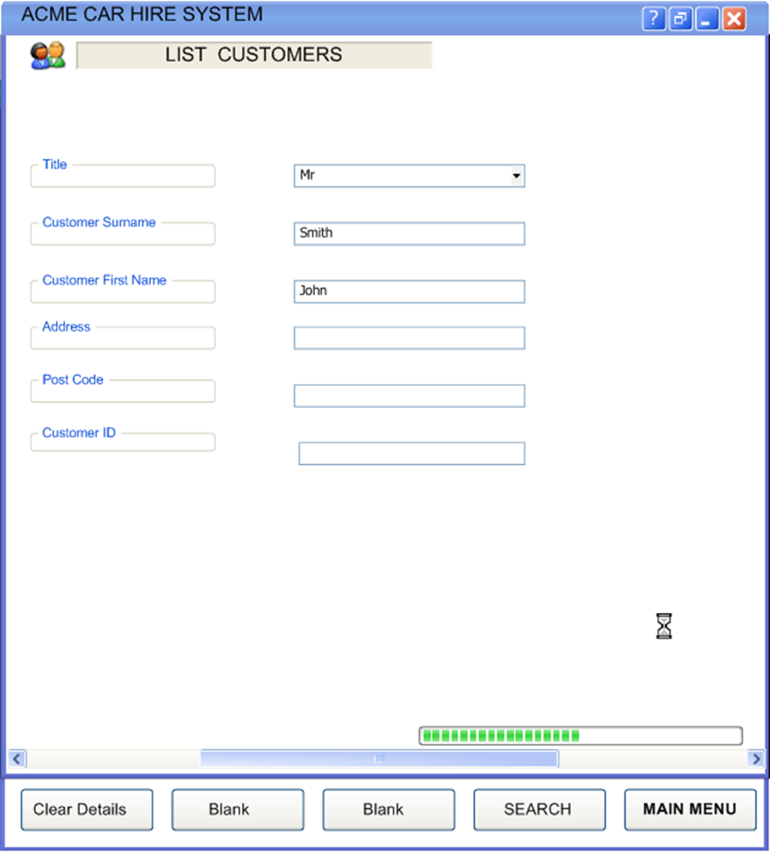

2.2.2 Screen 2. List of Customers
Screen 2 shows all four customers with their addresses that have the name ‘Mr John Smith’. If no customers of this name are found, Screen 6 is displayed.

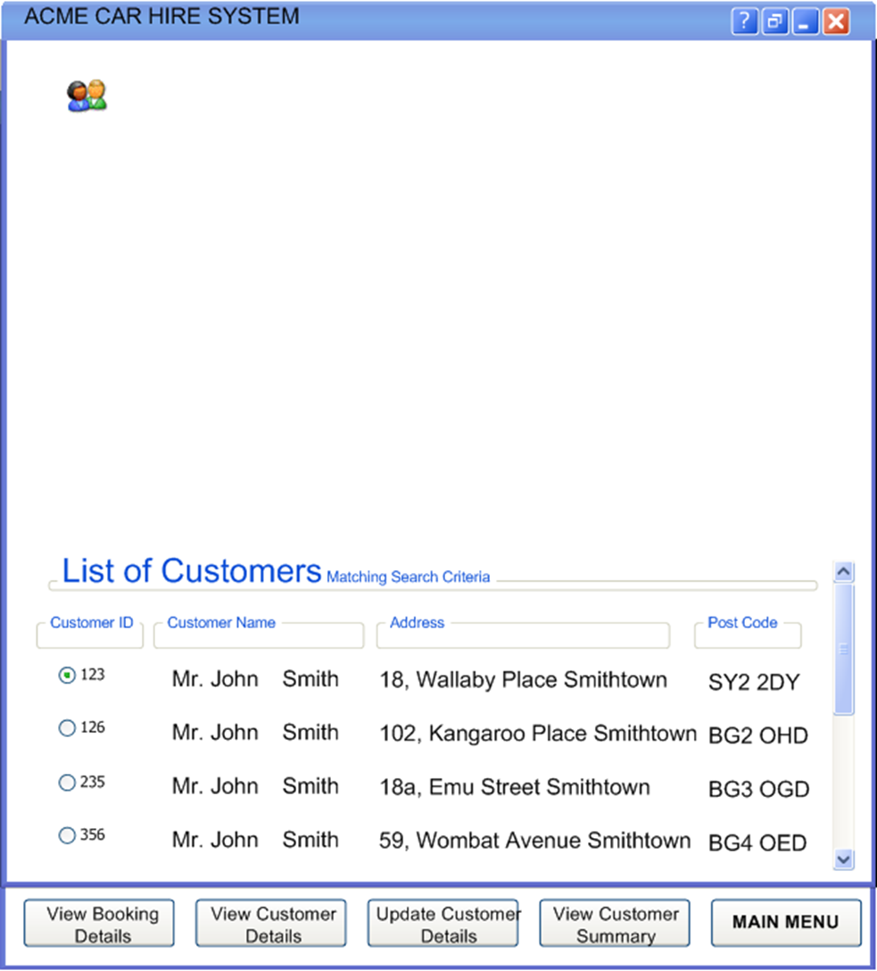

2.2.3 Screen 3. Customer Summary
The User presses the radio button on Screen 2 corresponding to the customer he is really searching for (in this case the first of the four John Smiths). If the user next presses the ‘View Customer Summary’ button, then this Screen 3 is displayed.
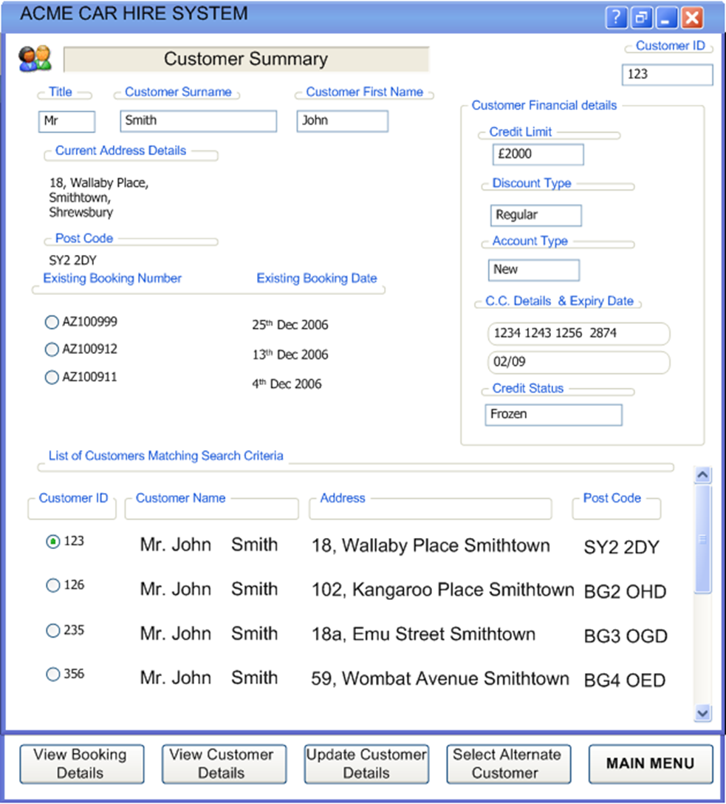
Screen 3 still displays the original four Mr John Smiths and their addresses, but also a summary of the data held about the selected Mr John Smith.

2.2.4 Screen 4. View/Update Customer Details
If the user presses either the ‘View Customer Details’ or ‘Update Customer Details’ buttons at the bottom of Screens 2 or 3, then this Screen 4 is displayed.
Note: the Measurer learns from using the system that if Screen 4 is displayed after pressing ‘View Customer Details’, then no fields may be updated. But if Screen 4 is displayed after pressing ‘Update Customer Details’, then many fields may be updated. Further, the Measurer learns that only certain authorized users may display Screen 4 in ‘Update’ mode and make changes to the displayed data. In contrast, any user may display Screen 4 in ‘View’ mode. The functionality that controls which users may view Screen 4 in ‘Update’ mode is outside the scope of the measurement.

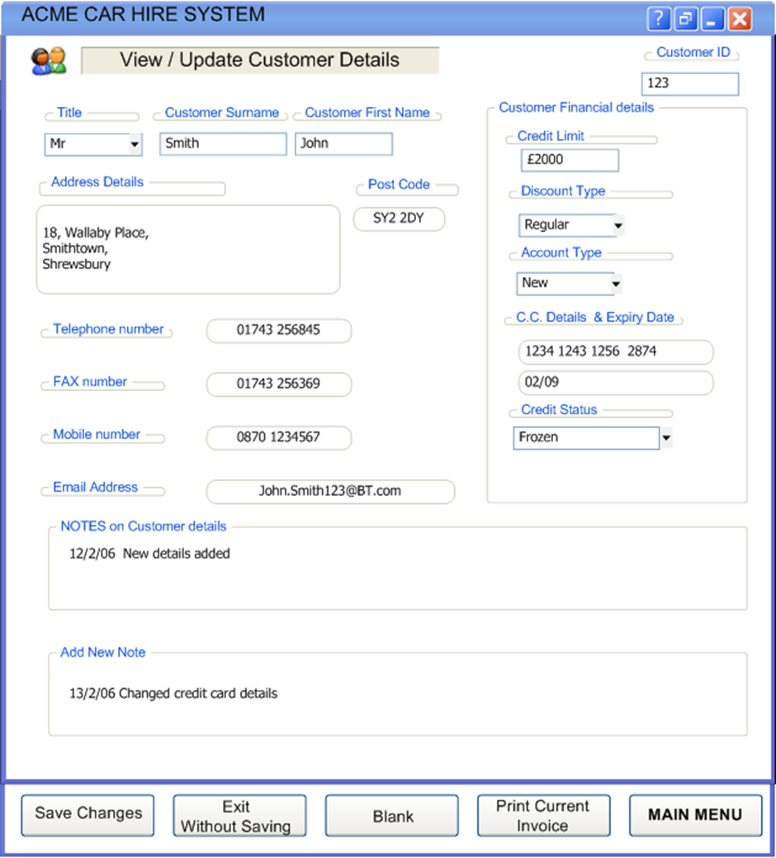

2.2.5 Screen 5. Print Preview of Customer invoice
Following the ‘View’ or ‘Update’ of Customer Details from Screen 4, the user has the option to display a Print Preview of the current Invoice for this customer, as Screen 5.

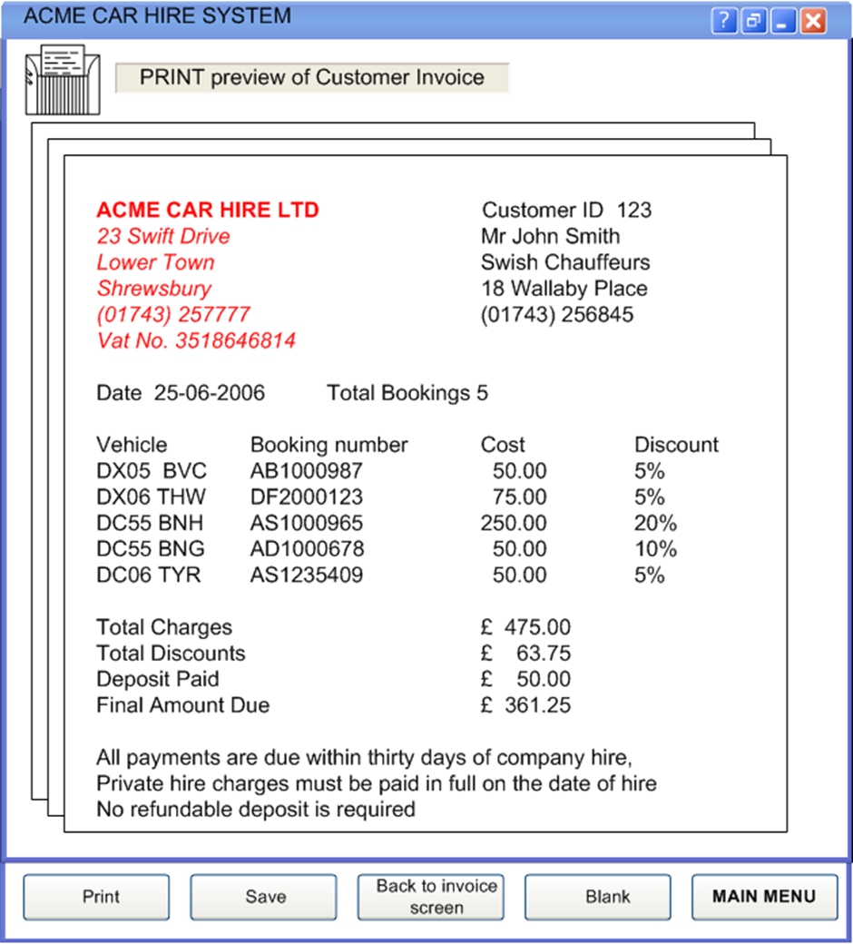

2.2.6 Screen 6. Error: Customer not found
If, when entering a customer name in Screen 1, no customer is found with that name, then Screen 6 is displayed. Another name, or a corrected name, may then be entered and searched.

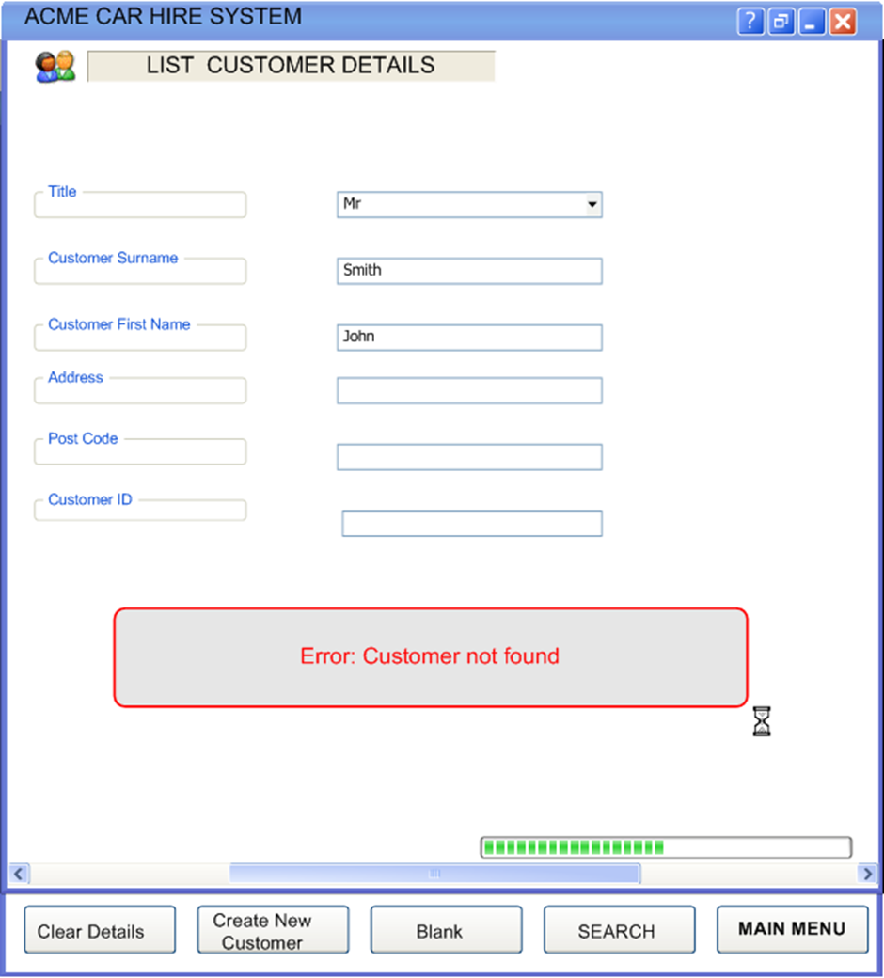

2.2.7 Screen 7. Create Customer Details
As a result of Screen 6 showing the error message ‘Customer not found’, the user has an option at the bottom of Screen 6 to ‘Create New Customer’, i.e. to enter data about a new customer. This results in the display of the Customer data entry Screen 7, with a system-generated ID for the new customer. Pressing ‘Add New Customer’ at the bottom of this screen results in saving the new customer details.

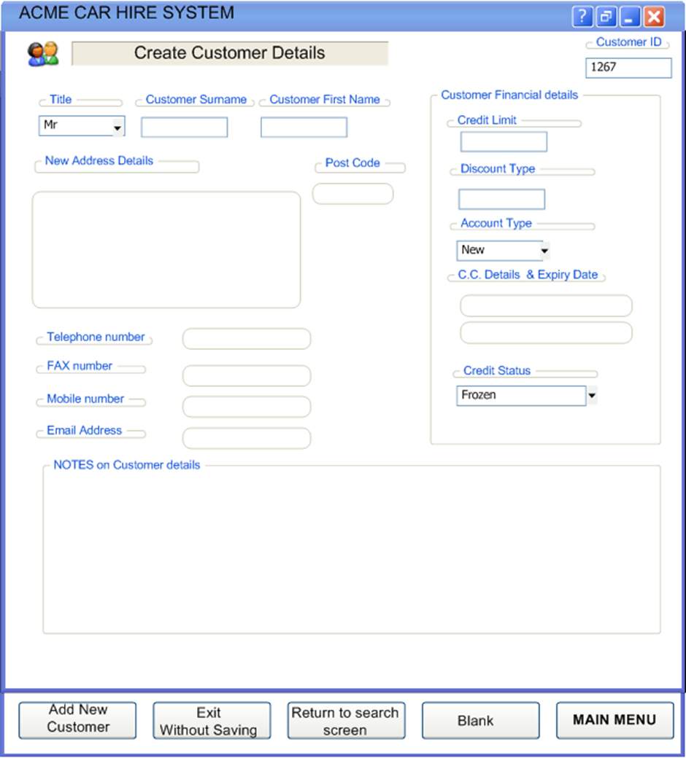

3

3 MAPPING AND MEASUREMENT PHASES
As for practical reasons this chapter also contains the measurement result, the Mapping phase is combined with the Measurement phase.
N.B. The detail in the following analysis is provided for training purposes. In practice, it would not be necessary to document the analysis and the measurement in this detail. Section 3.7 shows a simple spreadsheet to document the measurement. (The context and the assumptions made in the measurement should also be described).

3.1 Navigation of the screens via the control buttons
The Measurer finds it helpful to draw a model of how the seven screens may be navigated, using names on the control buttons. Figure 3.1 shows these possible navigation paths relevant to the measurement scope, including the screen number(s) on which the control button appears.
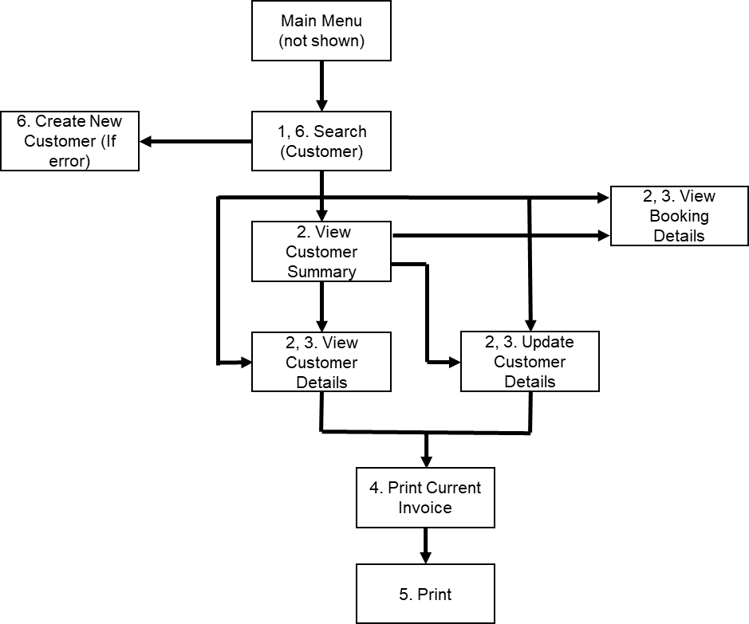
Figure 3.1- Navigation possibilities via the control buttons on the seven screens
Note: buttons such as ‘Save’ or ‘Main Menu’ or ‘Back to invoice screen’ that are not relevant to the navigation over the seven screens are not shown in Figure 3.1.
These navigational control buttons provide us with good evidence for identifying the functional processes, since each button selection requires a separate decision by the human functional user, which is a key criterion for distinguishing functional processes. However, to be sure, we should also check the mapping of the physical screen layouts to the (logical) functional processes.

3.2 Mapping the physical screen displays to the COSMIC concepts
We first note that the physical screens do not map one-to-one with functional processes.
- Screen 3 (‘Customer Summary’) shows the summary data about a selected customer, but also continues to display the output of Screen 2 (‘List of Customers’). The design of the display is helpful to a user to check that he has really found the correct ‘Mr John Smith’. But the two parts of the display show the output of two separate enquiry functional processes that serve different purposes:
- ‘Enquire if a customer of a given title and name exists in the system’;
- ‘Display summary data for all customers with the given title and name’ (to enable the user to select the customer of interest).
When the user is certain he has identified the correct customer, this screen then provides the input to three other functional processes (‘View Booking Details’, ‘View Customer Details’ and ‘Update Customer Details’ as well as a button that enables the user to repeat the display of ‘Customer Summary’ for an ‘Alternate’ customer, i.e. to invoke another occurrence of the ‘Display summary data’ process.
- Screen 4 (‘View/Update Customer Details’) also serves two separate functional processes. It is the output screen resulting from pressing ‘View Customer Details’ on Screen 3 but also serves as the data input screen for the ‘Update Customer Details’ process. ‘View’ and ‘Update’ are clearly two separate functional processes.
Figure 2.1 which shows a possible sequence of using the seven physical screens does not therefore reveal the functional processes directly. In contrast Figure 3.1, which shows all the possible flows from pressing the navigation control buttons relevant to the scope of the measurement, is much more helpful for identifying the functional processes.
Note, however, that the control buttons at the bottom of each screen have various roles. Some examples:
- The ‘Clear Details’ button on Screen 1, and the ‘Print’ button on Screen 5 are pure ‘Control Commands’ in the COSMIC sense (See [2], section 3.5.10, or [3], section 4.4.1). They should be ignored.
- The ‘View Customer Details’ button on Screen 2 and the ‘Back to Invoice Screen’ on Screen 5 are sub-menu navigation commands (therefore also pure Control Commands). They should be ignored.
- The ‘Print Current Invoice’ button on Screen 4 is a Control Command that invokes the triggering Entry for a functional process that does not require any data to be physically entered. The Customer ID is needed in order to determine the Customer's Current Invoice. Pressing the print button initiates this Entry data movement that starts the functional process.
- The ‘Print’ button on Screen 5 is assumed to be a Control Command that prints whatever is on the screen at the moment, or what is selected on the screen.

3.3 Identifying the functional processes
The triggering event(s) and functional processes are identified and listed in Table 1. The ‘Screen’ numbers in this table show the screen numbers for input and the output data, respectively.

Table 1: List of candidate triggering events and candidate functional processes
Screens | Triggering event: A User wants to: | Functional Process
1 (in),  2 or 6 (out) | Enquire if a customer of a given name exists in the system | List customers
3 (in)  3 (out) | Display data to enable the user to select the customer of interest (where more than one customer with the same given name exists) | View customer summary
2 or 3 (in)  4 (out) | View the detailed data for the selected customer | View customer details (Enquiry)
2 or 3 (in)  4 (out) | Display the detailed data for the selected customer before updating the customer details | View customer details (pre-Update)
4 in and out | Update the data for the selected customer | Update customer details
4 (in)  5 (out) | Display a Print Preview of the current Invoice for the selected customer | Display invoice print preview
7 (in) | Enter details for a new customer | Create new customer
2 or 3 (in)  (No out screen) | Display bookings for a given customer | View customer bookings details

Identifying the functional processes should be straightforward to an experienced Measurer. Only two points are worth noting.
- The buttons on Screens 2 and 3 ‘View Customer Details’ and ‘Update Customer Details’ both result in the display of Screen 4. The difference is that Screen 4 does not allow any updates if the ‘View Customer Details’ button was pressed, but does allow updates if the ‘Update Customer Details’ button was pressed. As the two processes result from different user decisions (‘I only want to view’ or ‘I want to update’), there must be two functional processes (see [3], the last paragraph of section 4.1.5.)
- When the ‘Create New Customer’ button on Screen 6 is pressed, it appears that the data entry Screen 7 includes the Customer ID already provided by the system. This might be interpreted as implying an Exit data movement from a functional process, but that would be a mistake. The Customer ID is a field on Screen 7 for entering data about a new customer and is therefore an attribute of the ‘Customer details’ data group moved by the triggering Entry for this ‘Create’ functional process. It should make no difference to the size measurement whether the user happens to enter the customer ID or whether the software creates the ID and pre-fills the data-entry screen with the ID.

3.4 Identifying the objects of interest
There are three objects of interest in the system that are in the scope of the measurement. We can tell that they are different objects of interest because they have different frequencies of occurrence (See Figure 3.2, where the ‘crows-foot’ sign indicates one-to-many.)
‘Vehicle’ is shown in dotted outline because it appears from the data on the screens and an assumption (see the Note below) that the functional processes within the scope do not need to access vehicle records. So with this assumption, ‘vehicle’ is not an object ‘of interest’ for this measurement.
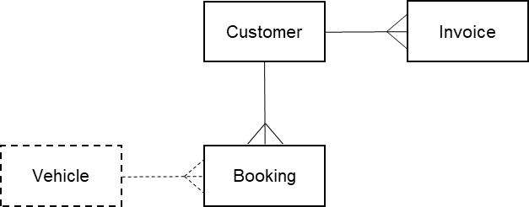
Figure 3.2 - The three objects of interest in the measurement scope

The objects of interest are listed below with their attributes that appear on the screens.
Customer: A person (or company?) registered in the ACME Car Hire system.
Key: Customer ID. Other attributes: title, name, address, notes, credit limit, discount type, account type, credit card number, expiry date and status,
Invoice: A statement for a given customer at a given date of the amount to be paid for one or more bookings.
Keys: (guess) Customer ID and Invoice date. Other attributes: customer name, address, total number of bookings, total charges, total discounts, deposit paid, final amount due, fixed text (payment terms).
Booking: A single Customer reservation for hire of a vehicle.
Key: Booking number. Other attributes: booking date, vehicle ID, invoice amount, discount %.
Vehicle: A vehicle owned by ACME that may be rented.
Key: Vehicle ID.
Note: The above interpretation of the data that appears on the screens makes an assumption about how a car hire system works, which might be obtained in practice via a system expert.
The assumption is that a ‘booking’ starts its life in the system with a status such as ‘reservation’. When the customer starts the hire period, a vehicle is assigned to the booking and the booking gets a status such as ‘rented’. At some time after the return of the vehicle, an invoice is issued for one or more bookings, at which point a booking gets the status ‘invoiced’ and data about the booking appears as an invoice-item. At this point in its life-cycle, therefore, booking’ is synonymous with ‘invoice-item’; they have a one-to-one relationship on the invoice. There is one underlying object of interest ‘booking’ for all statuses.

3.5 Identifying the data movements of the functional processes
The table below shows the functional processes identified in section 2.3.3, including all their movements of data groups (each of which describes an object of interest identified in section 2.3.4).
In the following, ‘Error messages’ means an error or confirmation message such as appears on Screen 6 for the ‘List customers’ functional process, or that it is reasonable to assume must exist for other functional processes.

Screens | Functional Process | Sub-process Description | Name of Data Group moved |  | Object of interest of Data Group moved |  | Data  Move-ment Type | CFP
1 | List customers | User enters a customer name | Customer name |  | Customer |  | E | 1
 |  | System searches the customer file for the entered name | Customer details |  | Customer |  | R | 1
2 |  | System displays customer name(s) that match the entered name, and other customer data | Selected customer data |  | Customer |  | X | 1
6 |  | Display error message if no customer is found with that name | Error Messages |  | Errors |  | X | 1
Total size |  |  |  |  |  |  |  | 4
2 | View customer summary | User selects a customer from the displayed list by pressing a radio button | Customer ID |  | Customer |  | E | 1
 |  | System searches the customer file for the selected customer ID | Customer details |  | Customer |  | R | 1
 |  | System searches to see if the customer has any bookings | Booking details |  | Booking |  | R | 1
3 |  | System displays customer summary data | Customer summary data |  | Customer |  | X | 1
3 |  | System displays current booking(s) for the customer | Current booking |  | Booking |  | X | 1
Total size |  |  |  |  |  |  |  | 5
2 or 3 | View customer details (Enquiry) | User presses ‘View customer details’ button | Customer ID |  | Customer |  | E | 1
 |  | System retrieves details for the selected customer ID | Customer details |  | Customer |  | R | 1
4 |  | System displays details for the selected customer ID | Customer details |  | Customer |  | X | 1
Total size |  |  |  |  |  |  |  | 3
2 or 3 | View customer details (pre-Update) | User presses ‘Update customer details’ button |  | Customer ID |  | Customer | E | 1
 |  | System retrieves details for the selected customer ID |  | Customer details |  | Customer | R | 1
4 |  | System displays details for the selected customer ID |  | Customer details |  | Customer | X | 1
Total size |  |  |  |  |  |  |  | 3
4 | Update customer details | Having pressed ‘Update Customer Details’ on Screen 2 or 3, the user now enters changed customer data on Screen 4 and presses ‘Save details’ | Customer details |  | Customer |  | E | 1
 |  | System updates customer record | Customer details |  | Customer |  | W | 1
4 |  | (Assumption). There will be error messages from validation failures | Error Messages |  | Errors |  | X | 1
Total size |  |  |  |  |  |  |  | 3
4 | Display invoice print preview | User presses ‘Print Current Invoice’ for the customer whose details are displayed | Customer ID |  | Customer |  | E | 1
 |  | System searches for the selected customer in order to find any bookings that have status ‘rented’ (so not yet ‘invoiced’) | Customer details |  | Customer |  | R | 1
 |  | System retrieves bookings for the customer that must be invoiced | Booking details |  | Booking |  | R | 1
5 |  | System displays invoice header and account summary details | Customer Invoice data |  | Invoice |  | X | 1
5 |  | System displays data for each invoiced booking | Booking invoice data |  | Booking |  | X | 1
5 |  | (Assumption). An error message will be issued if no invoice is due | Error Messages |  | Errors |  | X | 1
Total size |  |  |  |  |  |  |  | 6
7 | Add new customer | System enters data for new customer and presses ‘Add new customer’ button | Customer details |  | Customer |  | E | 1
 |  | System creates new customer record | Customer details |  | Customer |  | W | 1
 |  | (Assumption). There will be error messages from validation failures | Error Messages |  | Errors |  | X | 1
Total size |  |  |  |  |  |  |  | 3
2 or 3 | View customer booking details | User presses ‘View Booking Details’ for the customer whose data is displayed | Customer ID |  | Customer |  | E | 1
 |  | System searches for the selected customer in order to find any bookings | Customer details |  | Customer |  | R | 1
 |  | System retrieves bookings for the customer | Booking details |  | Booking |  | R | 1
Not shown |  | (Assumption) some customer data must be displayed | Customer summary data |  | Customer |  | X | 1
Not shown |  | System displays booking details | Booking details |  | Booking |  | X | 1
 |  | (Assumption). An error message will be issued if no bookings exist | Error Messages |  | Errors |  | X | 1
Total size |  |  |  |  |  |  |  | 6

3.6 Exploring hidden functionality - Exercises
The above measurement results are based on the data shown on the physical screens and some observations and assumptions that have been documented.
But there is almost certainly more ‘hidden functionality’ that is not immediately obvious from the physical Screens. It would be good practice for the Measurer to ask a system expert about possible hidden functionality, such as the following. Possible questions are presented as exercises for the reader.
Question 1.
We have assumed that on Screen 3, if the user first presses a radio button for another of the ‘Mr John Smiths’ and then presses the ‘View Alternate Customer’ button, this means that the details of the other John Smith are displayed on the same screen. This sequence implies that the user is invoking another occurrence of the ‘View customer summary’ functional process. Instead, suppose that pressing this button takes the user back to Screen 2 to enter another name, would this change the size measurement?
Answer.
There would be no effect on the size. The button ‘View Alternate Customer’ is for navigation purposes. We do not need to know the outcome of pressing the ‘View Alternate Customer’ button for the measurement.
Question 2.
On Screen 4 in ‘Update Customer Details’ mode, there is an option to ‘Add New Note’. We have assumed in the analysis above that there is one attribute of a customer called ‘Notes’. But it is possible that a separate Note record is created (with the date as part of its key) every time a new Note is written for a given customer. In this case there would be a one-to-many relationship between the objects of interest ‘Customer’ and ‘Customer Note’ and the latter should also appear as an object of interest on Figure 3.1. If this latter assumption is correct, what would be the effect on the sizes measured?
Answer.
The two ‘View Customer Details’ functional processes would have one additional Read to retrieve, and an Exit to display, one or more ‘Customer Notes’. Further, both the ‘Add new customer’ and the ‘Update customer details’ functional processes would have an additional Entry and a Write to enter and store a new ‘Customer Note’. The total increase in size with this assumption would be eight CFP.
Question 3.
In the real-world, customer attributes such as his/her address, credit card number, etc., change over time.
Normal business practice suggests that it would be wise for the ACME Company to create ‘history’ records for the replaced data values of certain customer attributes (rather than just over-writing the out-of-date values). Customer attributes that may change and for which it is worth keeping history records include:
- Customer address
- Customer account (because ‘credit limit’ and ‘account status’ might change)
- Credit card
If each of these ‘things’ becomes the subject of a history record, with different frequencies of occurrence, it would now be an object of interest rather than a customer attribute. (Example: the object of interest ‘Customer’ would have a one-to-many relationship with the object of interest ‘customer address’.)
What would be the effect on the measured sizes if history records must be maintained for these three ‘things’?
Answer
For these three ‘things’ that have become objects of interest, we might expect the following
- Assuming the ‘Customer details’ data group contains the current values and that the ‘View’ functional processes are required to show only the current values (and not the history of the values), there would be no effect on the size of these processes.
- However, there would almost certainly be a need for the user to display the history of these three objects of interest. This implies three additional ‘Display history’ functional processes having one Entry, one Read and two Exits (one for the data value plus an error message for when there is no history record). The total increase in size is then 3 x 4 = 12 CFP.
- The ‘Update Customer Details’ functional process would have three additional Writes to store a history record for each of the three objects of interest.
Question 4.
We do not know how the Cost and the Discount shown on Screen 5, ‘Print Preview of Customer Invoice’, are calculated. ‘Cost’ presumably varies with ‘Vehicle Class’ and the duration of the hire. ‘Discount’ varies with the booking in rather complex ways that are not clear. We also see from the ‘Customer details’ on Screen 4 that ‘Discount Type’ is a variable for a customer. However, the actual discount for an individual booking must vary with one or more other factors, since all invoice items are for the same one customer. (Does the discount also vary over time, with hire duration, with vehicle-class, or whatever? We don’t know.)
Assume that, as well as varying with customer, the discount applicable to a booking varies with ‘Vehicle-class’ and that ‘Vehicle-class’ is an attribute of the object of interest ‘Vehicle’. Assume also that the discount is applied at the time the invoice is calculated. With these assumptions, what would be the effect on the size of the ‘Display invoice print preview’ functional process?
Answer.
First note that the ‘Vehicle ID’ is shown as one of the booking attributes. The ‘Display invoice print preview’ functional process would therefore need an additional Read of the object of interest ‘Vehicle’ associated with the booking to obtain its ‘Vehicle-class’. As the functional process already has the ‘Discount type’ from the ‘Customer details’ record, the applicable discount can be obtained. The size of this functional process would increase by one CFP.
Question 5
The ‘Print Preview’ screen shows that the Customer ID, name and address are output. Why is no Exit measured for this data describing the object of interest ‘Customer? Also, why is no Exit measured for the output of the three lines of fixed text describing invoice payment terms?
Answer
The three attributes Customer ID, name and address are all attributes describing the object of interest ‘invoice’. If we wish to be really precise in attribute naming, they should really be called ‘ID of the customer invoiced’, ‘name of the customer invoiced’ and ‘address of the customer invoiced’ respectively. The purpose of this process is to output data about an invoice, not about a customer. Therefore, the fixed text is also data about the invoice (see the attributes of the object of interest ‘Invoice’)..
If pieces of text such as this were stored by the Car Hire system as variables that could be edited by an administrator, then they still remain attributes of the invoice. In the case of an administrator as an editor there will be additional functional processes to edit the fixed text, with the administrator as functional user and ‘fixed text’ as its object of interest .
Question 6. (An exercise in measuring a Change Request)
Suppose there is a requirement to add the customer’s ‘Driving License No.’ to the Customer details record. For all functional processes within the scope of the measurement, what would be the size of this change and the increase in functional size (if any) of the software?
Answer.
An extra attribute would need to be included in the Entry and Write of the ‘Update customer details’ and ‘Create new customer’ functional processes and on the Read and Exit of both ‘View customer details’ functional processes. In total the size of the change requirement is 8 CFP, because eight data movements must be changed.
In addition it is possible that the error messages for the Update and Create functional processes would need to be changed to handle validation failures of the customer’s ‘Driving License No’. This would add a further 2 CFP to the size of the required change.
The total size of the Change Request would therefore be 10 CFP.
As no new data movements are added, and none are deleted, the size of the ACME Car Hire software measured in CFP would not be changed as a result of this Change Request.

3.7 ACME Car Hire System. Summary COSMIC size measurement.
Table 3 below summarizes the results of the analysis given in section 3.5. It shows the functional processes and their sizes for which direct evidence is available from the screens, or where reasonable assumptions have been made about the existence of data movements. (We have assumed a total of 4 CFP for which there is no direct evidence, of which 3 CFP are for assumptions that error messages must be present).
Table 3: List of the functional processes and their sizes
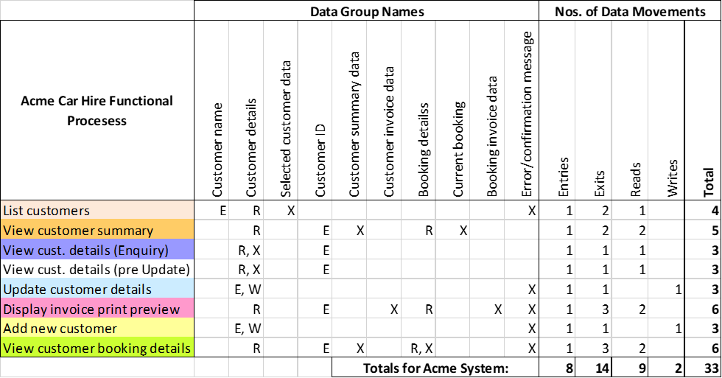
Table 4 shows the possible sizes to be added to account for the ‘hidden functionality’ identified in Questions 2 – 4, as discussed in section 3.6.
Table 4: ‘Hidden functionality’ and the possible effect on sizes of Functional Processes
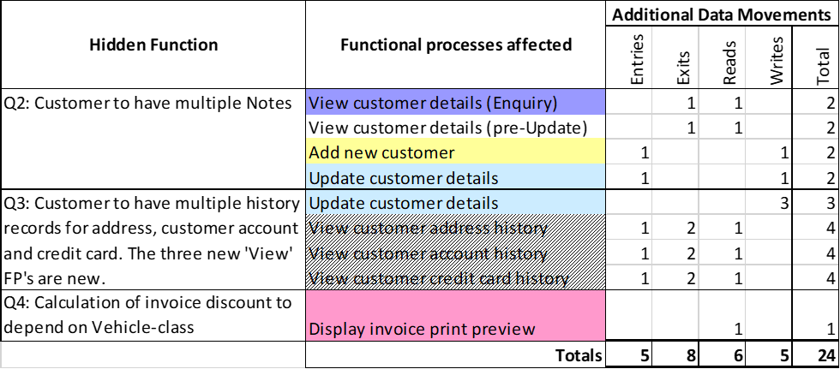
The very important lesson from the Measurer asking questions to a system expert about how the ACME Car Hire system works in practice is that it may lead to discovering much more functionality (and thus extra size) than was first apparent from examining only the data shown on the physical screens.
In this case, if the assumptions about how to deal with hidden functionality are correct, the total size at 57 CFP is 73% greater than was first apparent.
References

REFERENCES
All COSMIC documents are available for free download from www.cosmic-sizing.org.

- Introduction to the COSMIC method of measuring software.
- The COSMIC Functional Size Measurement Method Measurement Manual. (The COSMIC Implementation Guide for ISO/IEC 19761.
- Guideline for Sizing Business Application Software.

Appendix

ACKNOWLEDGEMENTS
This case study was kindly provided by Capgemini UK. The measurement of the COSMIC Function Point sizes was made in collaboration with the Capgemini reviewers shown below.

Version 1.0.1 reviewers
Mike Eagles  Capgemini  UK | Paul Hope  Capgemini  UK | Arlan Lesterhuis  MPC COSMIC  The Netherlands
Bruce Reynolds  Telecote Research  USA | Francisco Valdés Souto, Spingere,  Mexico

Version 1.0 reviewers
Mike Downing  Capgemini  UK | Mike Eagles  Capgemini  UK | Paul Hope  Capgemini  UK
Phil James  Capgemini  UK | Arlan Lesterhuis  MPC COSMIC  The Netherlands | Bruce Reynolds  Telecote Research  USA
Charles Symons
COSMIC
UK

VERSION CONTROL
The following table gives the history of the versions of this document.
DATE | REVIEWER(S) | Modifications / Additions
April 2017 | COSMIC Measurement Practices Committee | First version 1.0 issued
August 2018 | COSMIC Measurement Practices Committee | Version 1.0.1 issued with some clarifications.

CHANGES IN V1.0.1 FROM V1.0 OF THIS GUIDELINE
Note. The nature of a change is indicated by
- ‘Method’ when a definition or rule of the COSMIC method has been changed
- ‘Editorial’ when the description of the guidance was changed to improve ease of understanding.
- ‘Correction’ when an error in the previous version v1.0 of this Guideline has been corrected.
References in version 1.0.1 | Nature of change | Comment
3.2 | Editorial | In the sentence ‘The ‘Print Current Invoice’ button on Screen 4…’ the different roles of the Control Command and the triggering Entry clarified.
3.2 | Editorial | Explained why the ‘Print’ button on Screen 5 doesn’t lead to another functional process.
3.3 | Editorial | The sentence ‘Every functional process must start with an Entry’ removed, in view of the Note to the GSM in MM 1.3.2. Also, the phrase 'The Customer ID...' is an explanation to the word ‘mistake’ in the previous sentence, the deleted sentence disturbs this.
3.5  Question 5 | Editorial | Answer clarified

CHANGE REQUESTS, COMMENTS, QUESTIONS
Where the reader believes there is a defect in the text, a need for clarification, or that some text needs enhancing, please send an email to: mpc-chair@cosmic-sizing.org
You can use the forum on cosmic-sizing.org/forums to post your questions and receive answers from our world-wide community. The quality of any answers will depend on the knowledge and experience of the community member that writes the answer; the MPC cannot guarantee the correctness. Commercial organizations exist that can provide training and consultancy or tool support for the method. Please consult the www.cosmic-sizing.org web-site for further detail.

